Office: 2424 Hwy 47 / Mail: P.O. Box 170, Belen, NM 87002

Phone: (505)864-8914 / www.valenciaswcd.org

Valencia Soil and Water Conservation District Scholarships:

DAN GOODMAN SOIL and WATER CONSERVATION and ENVIRONMENTAL IMPROVEMENT AWARD

OBJECTIVE
The Dan Goodman Soil and Water Conservation and Environmental Improvement Award is an annual scholarship from the Valencia Soil and Water Conservation District that is awarded to one or more deserving high school students (grades 9-12) residing within the Valencia Soil and Water Conservation District boundaries* who have demonstrated a high regard for conservation and the environment. The objective in giving these awards is to stimulate activities, teaching, and learning in this area, and to reward those who have been active in conservation.

WHO CAN APPLY?**
- Any high school student living within Valencia Soil and Water Conservation District boundaries, actively enrolled in grades 9-12, may apply for this award.
- Applicants must document all past projects, services, or workings in soil and water conservation and/or environmental activities.
- Students active in any conservation and/or environmental areas should apply.
- Judging criteria will be based on all or any of the following:
-Farm and ranch experience, or community-garden experience
-Experience in environmental issues
-Past or ongoing projects in these areas
-Grade point average
-Class rank
-Community service
-School services and activity in related organizations (Such as FFA, 4-H, Scouts, etc.)
-Career plans
-College or technical school education plans following high school
-Awards, honors, and scholarships received
-Other criteria that the applicant sees fit to document
- Anyone who has received this award in the past can still apply again, with a maximum of two awards per applicant allowed over the course of a student’s high school years.
- All who have applied, who have not been selected, but who are still within grades 9-12 are encouraged to reapply in subsequent years.

Applications
- Application forms can be obtained in a variety of ways: 1) from the Valencia Soil and Water Conservation District office, 2424 Highway 47, Belen, NM 87002; 2) by e-mailing a request to vicechair@valenciaswcd.org; 3) by asking your high school counselor or student services advisor.
- Applications for this award must be submitted to the Valencia Soil and Water Conservation District, attention Vice Chair Smith de Cherif and Board Member Cordova, by Wednesday, May 31, 2023. Applications can be submitted in a variety of ways: 1) via U.S. Mail, Valencia Soil and Water Conservation District, Post Office Box 170, Belen, NM 87002; 2) in-person delivery to the District office (see above for physical address); or 3) by emailing vicechair@valenciaswcd.org

- Award recipients will be selected at the District’s June 2023 regular Board meeting, and winners will be notified shortly thereafter.

AMOUNT
Up to three awards of $500-$1,000.

AWARD PROCESS
A committee composed of members from the Valencia Soil and Water Conservation District Board of Supervisors will review the applications; the full Board will designate the winner(s). Individuals may be requested to attend an interview.
________________________________________________________________________________________
* The map of the Valencia Soil and Water Conservation District is on page 6 of this application. This map can be accessed on our website: See ValenciaSWCD.org, click on “About Us,” and scroll down to the map. The District includes all of Valencia County, northern Socorro County, the Pueblo of Isleta, and most of the Pueblo of Laguna.
** Applications will be accepted, and awards made without regard to race, color, gender, age, religion, national origin, marital status, or disability.

Valencia Soil and Water Conservation District Scholarships:

APPLICATION for the

DAN GOODMAN SOIL and WATER CONSERVATION and ENVIRONMENTAL IMPROVEMENT AWARD

Please complete all the following questions.

Date: ___________________

1. Name____________________________________________________________________________
Last First Middle

2. Home Address______________________________________________________________________
Street or Post Office Box City
_________________________________________________________________
State Zip code

- Telephone Number____________________________________________________

- Date of Birth___________________________________________________

- Married: Yes______ No______

- Education:
  - High School_________________________________________________________________
Name Location

Grade: ____________ GPA:_____

  - Class rank: ___________________________
(Attach most recently available transcript copy)

  - Do you plan to attend college, university, or vocational school? Yes______ No______

  - List any other schools attended, such as community college, vocational school, industrial school, etc. Give dates of attendance and subjects studied.
_________________________________________________________________________________________________________________________________________________________________________________________________________________________________________________________________________________________________________________________________________________________________________________________________

- Employment (if applicable)
  - Employer: ________________________________________________
  - Address: _________________________________________________________
  - Period of employment: from____________ to _________________
  - Title of position: __________________________________________
  - Briefly describe duties of employment listed above:
_________________________________________________________________________________________________________________________________________________________________________________________________________________________________________________________________________________________________________________________________________________________________________________________________

- Discuss all past or current farm and/or ranch experience, community-garden experience, or experience in environmental issues, and conservation experience: ________________________________________________________________________________________________________________________________________________________________________________________________________________________________________________________________________________________________________________________________________________________________________________________________________________

- Discuss all agricultural experience, leadership roles, and activities that you have participated in during the last year.
________________________________________________________________________________________________________________________________________________________________________________________________________________________________________________________________________________________________________________________________________________________________________________________________________________

- List professional societies, civic organizations, important committees, community services, school services, and activity in any related organization, or other significant organizations or activities in which you participated.
________________________________________________________________________________________________________________________________________________________________________________________________________________________________________________________________________________________________________________________________________________________________________________________________________________________________________________________________________________________________

- List positions of leadership that you have held or now hold (4-H, FFA, student organizations, etc.): ________________________________________________________________________________________________________________________________________________________________________________________________________________________________________________________________________________________________________________________________________________________________________________________________________________

- List honors or special awards received in recognition of your school or community activities: ________________________________________________________________________________________________________________________________________________________________________________________________________________________________________________________________________________________________________________________________

- List the college, university, or vocational school where you plan to study and include location:
________________________________________________________________________________________________________________________________________________________________________________________________________________________________________________

- Do you hold other awards or scholarships at the present time? Yes______ No_______

- Attach a one-page letter outlining your background, commitment to conservation or the environment, objectives of your educational program, career plans, etc.

- Please attach a letter of recommendations to this application (no more than two letters of recommendation should be submitted).

- References
Give names, addresses, and phone numbers of references:

1. ________________________________________________________________
Name Office address

________________________________________________________________
City State Zip code

__________________________________

Phone number

2. ________________________________________________________________
Name Office address

________________________________________________________________
City State Zip code

__________________________________

Phone number

3. ________________________________________________________________
Name Office address

________________________________________________________________
City State Zip code

___________________________________

Phone number

Signature of Applicant Date

NOTE: Applications for this award must be submitted to the Valencia Soil and Water Conservation District by Wednesday, May 31, 2023 at 5:00 p.m. Applications can be submitted in a variety of ways:

1) Mail applications with all supporting materials to Vice Chair, Valencia Soil and Water Conservation District, Post Office Box 170, Belen, NM 87002.

OR

2) Hand deliver applications and all supporting materials to the Valencia Soil and Water Conservation District office at the Whitfield Conservation Area, 2424 Highway 47, Belen, NM 87002.

OR

3) E-mail applications and all supporting materials to vicechair@valenciaswcd.org

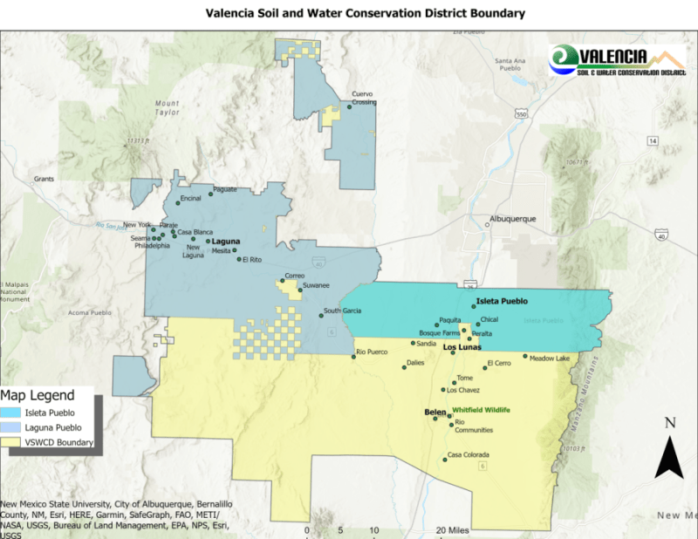

Note: The Valencia Soil and Water Conservation District includes the yellow, light blue, and turquoise shaded areas on the map above.

